Cloud-Native Inventory Management System for Small and Medium Retail Enterprises

Submitted by: Sibusiso Mathonsi
Date: 12 May 2026
Course: PROJECT

Table of Contents

- User Interface Design
- User Feedback and Design Iteration
- Entity Relationship Diagram
- Entity Descriptions
- Relationship Justification
- Technology Choice

1. User Interface Design
The user interface is designed according to the usability criteria established in Phase 3: Learnability, Efficiency, Memorability, Error Prevention, and Satisfaction. All interfaces follow a role-based access model, presenting only the functionality relevant to each actor identified in the Use Case Diagram. The design applies Nielsen's heuristics and ISO 9241-11 principles to ensure task completion with minimal cognitive load, particularly for users with limited digital literacy.

1.1 Login, Registration, and Authentication Screens
The authentication flow enforces the security non-functional requirements specified in Phase 2. All communication between client and server is secured via Transport Layer Security (TLS) version 1.3. Successful password-based authentication triggers a Multi-Factor Authentication (MFA) challenge using a Time-Based One-Time Password (TOTP). Upon full verification, the server issues a JSON Web Token (JWT) for stateless session management across all subsequent API requests. This multi-layered approach satisfies NFR-SEC-02 by ensuring that user identity is cryptographically verified before any access to inventory or financial data is granted.

Login Screen
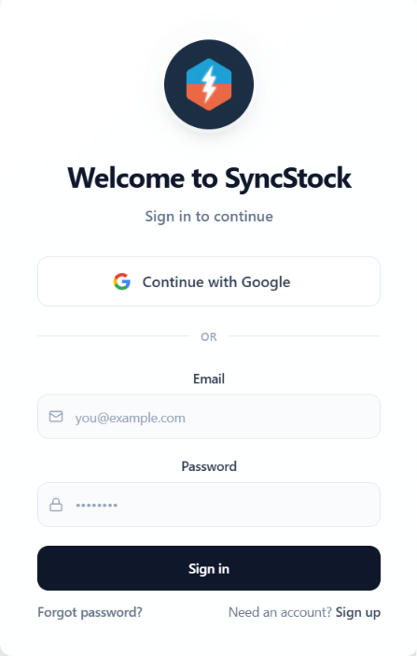

Registration Screen
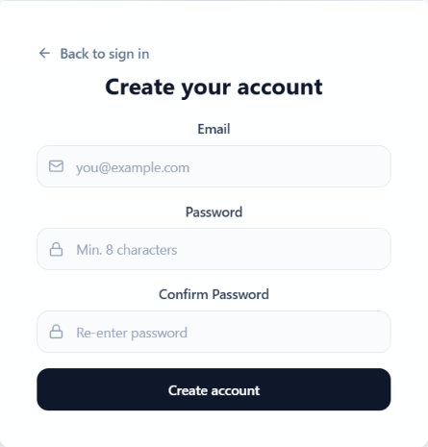

[INSERT SCREENSHOT: Multi-Factor Authentication Screen]
Figure 3: MFA Verification Screen

1.2 Home and Dashboard Interfaces
Dashboards are role-specific, presenting only the information and actions relevant to the actor's responsibilities.
The Store Manager dashboard serves as a strategic command centre, aggregating real-time data from the Inventory Service, Order Management Service, and Analytics and Forecasting Service. Key Performance Indicators (KPIs) including total daily sales, low-stock item counts, pending purchase orders, and gross margin are displayed as summary cards for at-a-glance situational awareness. A configurable chart visualises sales trends over time, and a table of top-selling products aids in merchandising decisions. A floating action button provides rapid access to manual purchase order creation. This interface directly fulfills the managerial review task identified in the Detect-to-Replenish Activity Diagram.
The Warehouse Staff dashboard is a mobile-first, task-oriented interface. It presents a prioritised list of pending physical tasks: receiving shipments, performing cycle counts, and picking orders for fulfillment. Each task is displayed as a large, tappable card with relevant contextual information such as purchase order numbers, aisle locations, and queue sizes. Navigation is deliberately restricted to three core functions—Tasks, Scan, and Profile—to reduce cognitive load and prevent navigational errors during high-speed physical work. This design applies the principle of recognition over recall, directly supporting the Memorability usability goal.

Store Manager Dashboard
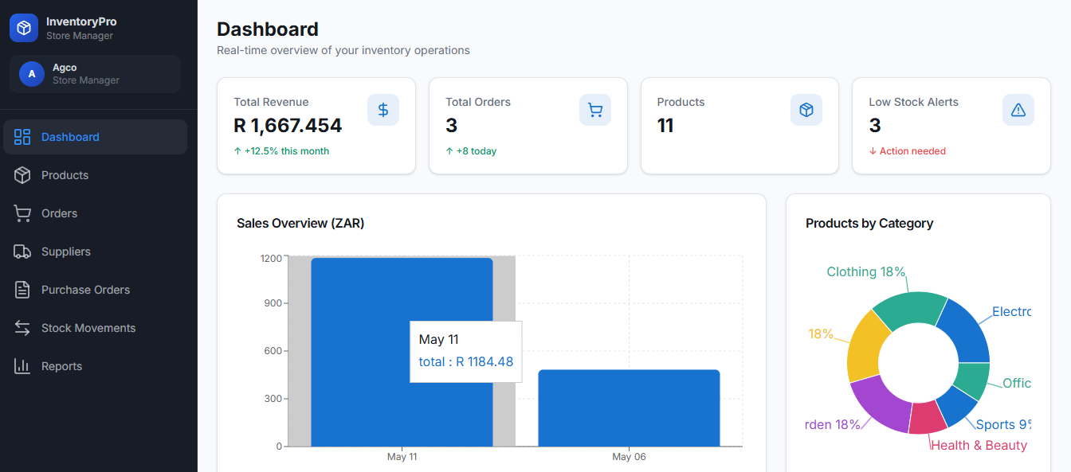

Warehouse Staff Mobile Dashboard
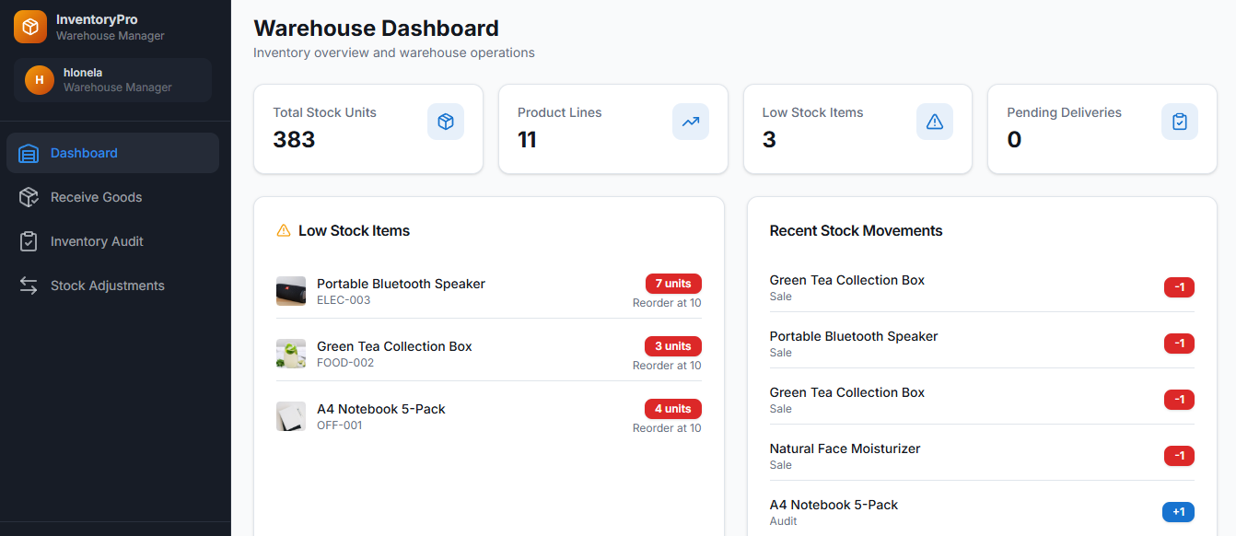
1.3 Data Entry Forms
Data entry forms implement the business processes mapped in Phase 2: Sales Transaction, Process Returns, Receiving Goods, and Inventory Audit. Each form prioritises barcode scanning as the primary input method to minimise manual keystrokes and reduce data entry errors, directly supporting the Efficiency and Error Prevention usability goals.
The Sales Transaction screen is designed for the cashier's high-speed transactional workflow. Scanned barcodes populate line items in real time, with the Inventory Service validating stock availability synchronously. A configurable grid of quick-product buttons enables single-tap addition of frequently sold, non-barcoded items. The running total, inclusive of tax, is displayed prominently, and payment processing is initiated via a clearly differentiated action button. The interface architecture supports the usability target of completing a five-item sale in thirty seconds or fewer.
The Process Returns form implements a two-step workflow. The cashier first scans the original receipt barcode to retrieve the transaction record, then scans the returned item barcode. The reason for return is captured via a set of clearly labelled, tappable buttons rather than a free-text or code-based field, applying the recognition over recall heuristic to improve learnability for new staff. Upon submission, the system publishes a StockReturned event to the message bus, instantly updating global inventory and eliminating the possibility of ghost stock.
The Receiving Goods form, used by warehouse staff on mobile devices, auto-populates the purchase order number and expected quantities from the Procurement Service. Staff scan each item barcode and verify or adjust the actual quantity received. A flagging mechanism allows immediate documentation of damaged or short-shipped items, triggering automatic notifications to the Store Manager and updates to the supplier's performance rating. The confirmation action is persistently visible, addressing the usability issue identified in Design Iteration 1.
The Cycle Count form supports the inventory audit process. The system triggers scheduled counts and directs staff to specific bin locations. Staff scan the bin barcode and each item barcode, then enter the physical count using stepper controls to minimise typing errors. A real-time progress indicator shows the number of items verified against the total required. All discrepancies are logged to the immutable audit trail for subsequent managerial review and approval.

Point-of-Sale Screen
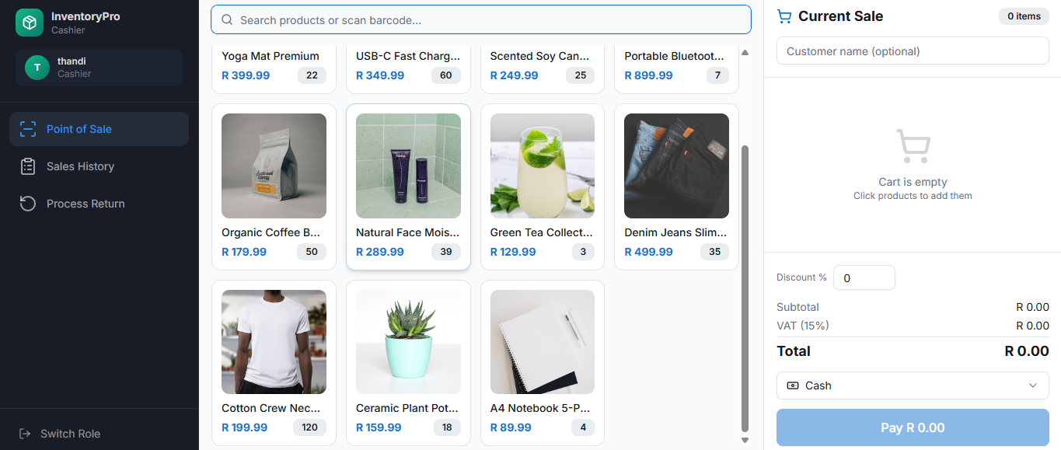

Process Returns Screen

Receiving Goods Mobile Screen
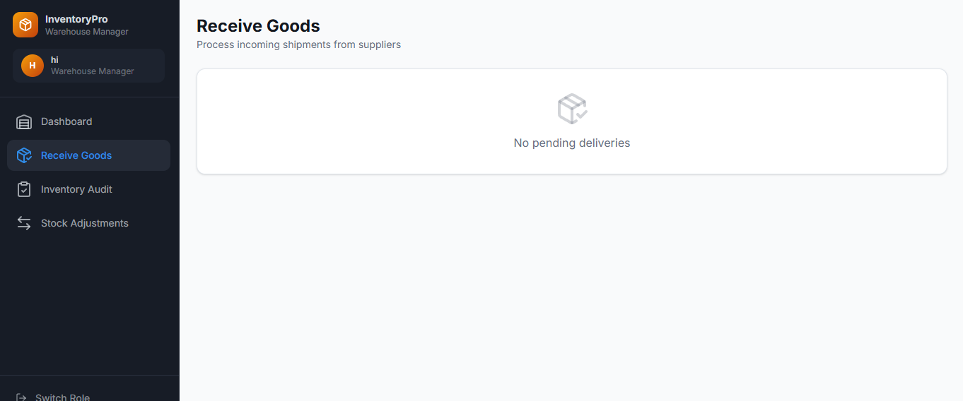

Cycle Count Mobile Screen
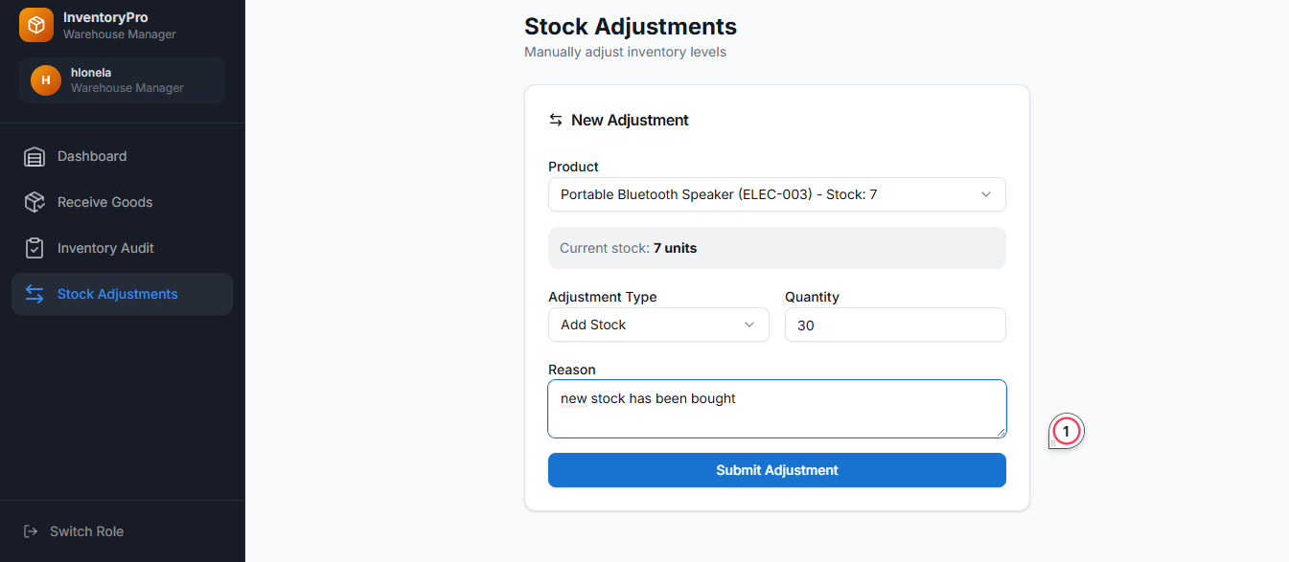
1.4 Report Generation Views
The Inventory Turnover and Forecasting Report visualises outputs from the Analytics and Forecasting Service. A configurable date range filter allows the Store Manager to specify the analysis period. The primary visualisation is a dual-line chart plotting historical sales data against the machine-learning-generated demand forecast over a twelve-month projection horizon. This makes complex time-series analysis immediately interpretable for decision-makers without statistical training.
Below the chart, a table titled "Recommended Purchase Orders" displays the system's calculated replenishment suggestions. Columns include the Stock Keeping Unit, product name, current stock on hand, monthly demand forecast, safety stock requirement, calculated reorder point, and suggested order quantity derived from the Economic Order Quantity formula. Each row includes an approval button, allowing the manager to convert a recommendation into a transmitted Purchase Order with a single action. This transforms inventory replenishment from a reactive, rule-of-thumb process into a proactive, data-driven function.

Inventory Forecasting Report
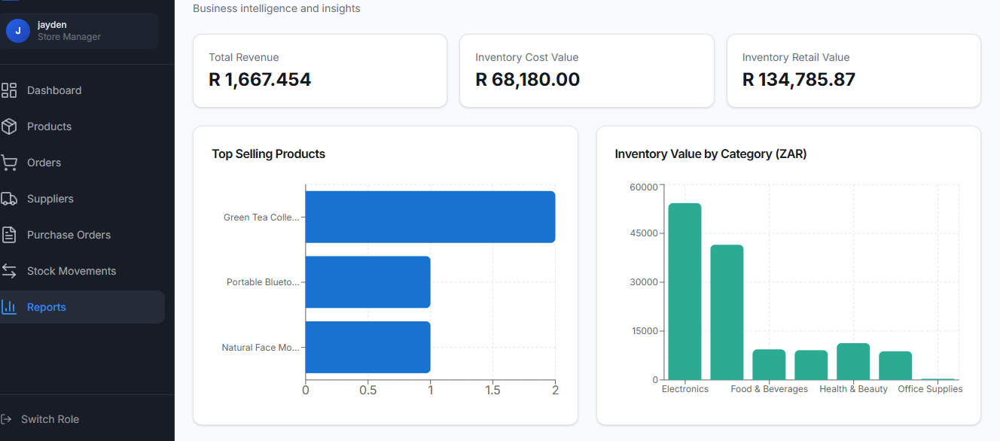

1.5 Admin and User Management Panels
The Role-Based Access Control (RBAC) Management Panel is accessible exclusively to users assigned the Admin role. It displays all system users in a tabular format with columns for name, email address, assigned role, account status, and last login timestamp. Inline editing allows the administrator to modify user roles and deactivate accounts. A dedicated action provides Multi-Factor Authentication reset capability for users who have lost access to their authenticator device. All modifications to user permissions are recorded in the immutable audit log, ensuring traceability for all access control changes and satisfying the accountability requirements of NFR-SEC-01.

User Management Panel
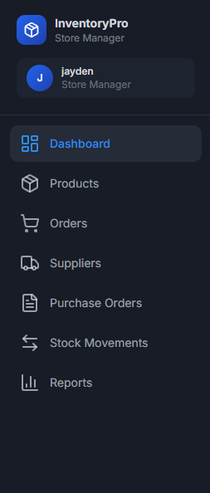

2. User Feedback and Design Iteration
This section documents the iterative refinement of the user interface based on empirical feedback obtained during prototype evaluation with representative users from the target SME demographic. Two significant revisions are presented, demonstrating the application of user-centred design principles.

Iteration 1: Visibility of the Save Action
During usability testing of the Cycle Count screen, four out of five warehouse staff testers were unable to locate the save function on their first attempt. The original design rendered the confirmation button as a low-contrast, text-only element positioned at the very bottom of a scrollable list. Testers reported that they believed the application had malfunctioned or that they lacked permission to save. This failure indicated a violation of Nielsen's "Visibility of system status" and "Recognition rather than recall" heuristics.
The revised design relocates the confirmation action to a sticky footer bar that remains fixed at the bottom of the viewport regardless of scroll position. The button was redesigned with high-contrast colour treatment to create an unambiguous visual affordance for the primary action. A real-time status counter displaying the number of items verified against the total was added to provide continuous system feedback. This change directly addresses the Error Prevention usability goal by eliminating the likelihood of a user exiting the screen without finalising their count.

Original Cycle Count Screen
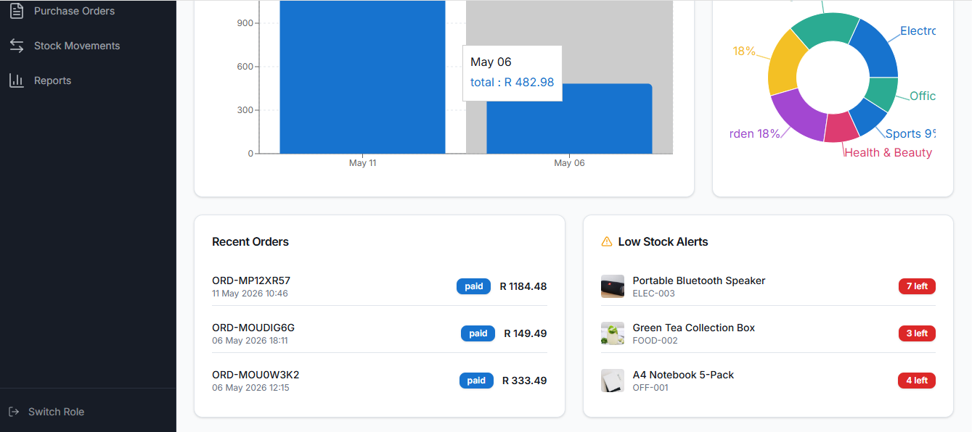

Revised Cycle Count Screen
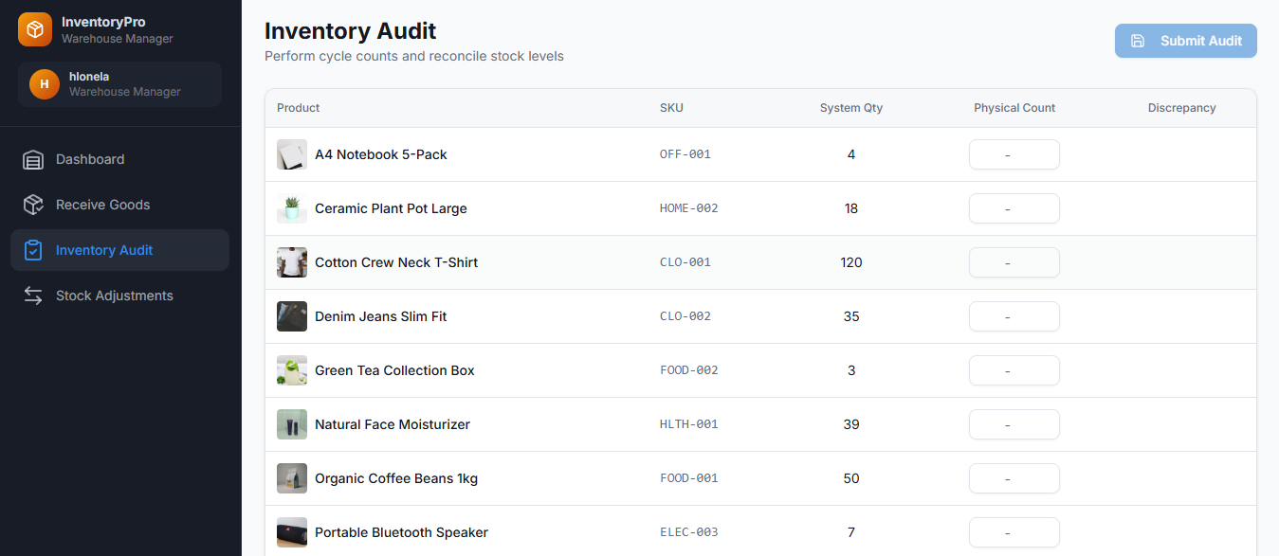

Iteration 2: Terminology and Input Method for Product Returns
Cashiers testing the Product Return screen reported significant difficulty with the terminology used in the original design. The input field labelled "Product ID" did not correspond to their operational vocabulary; testers stated they worked with barcodes, not internal identifiers. The second field, labelled "Reason Code," required users to memorise or look up numeric codes for return reasons, such as damaged packaging or expired products. This design violated the "Match between system and real world" heuristic by using system-oriented technical language instead of the user's natural vocabulary.
The revised design replaces the "Product ID" label with a barcode scanning interface, activated by default. The "Reason Code" text field was eliminated entirely and replaced with a set of large, clearly labelled, tappable buttons featuring both text descriptions and representative icons for the most common return reasons. The language used on these buttons mirrors the terminology cashiers use in their daily work. This substitution of a recognition-based interface for a recall-based one significantly improved task completion time and eliminated the need for new cashiers to consult external reference materials before processing their first return.

Original Product Return Screen

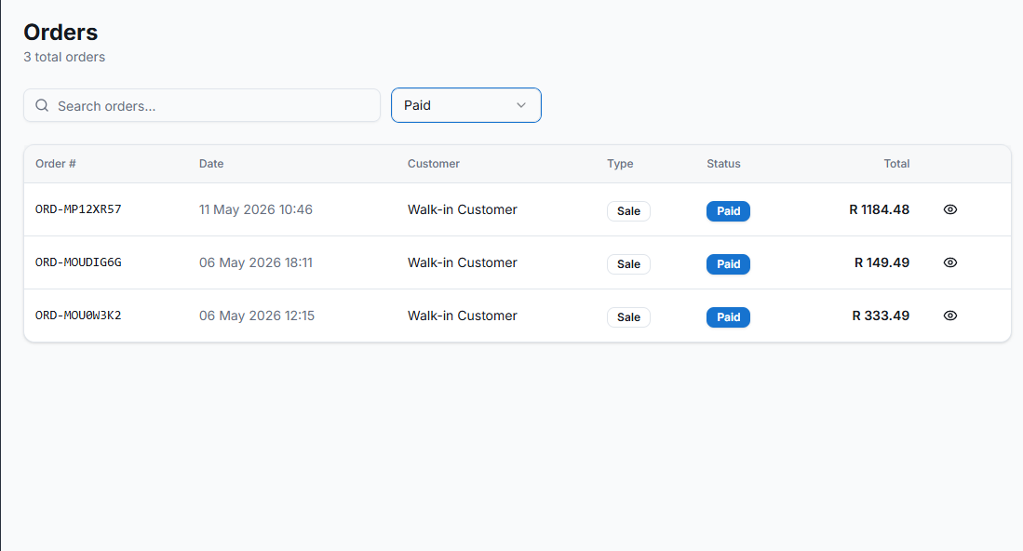

Revised Product Return Screen
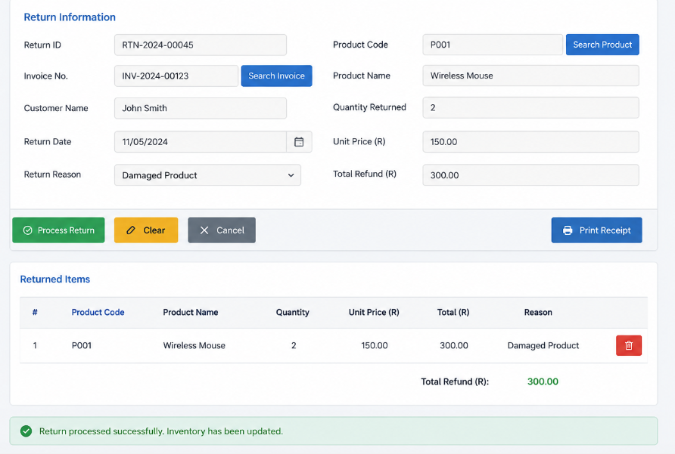

3. Entity Relationship Diagram
The Entity Relationship Diagram (ERD) presented below models the logical data structure of the system. In the physical implementation, these tables are distributed across separate databases owned by the Inventory, Order Management, and Procurement microservices, following the Database per Service architectural pattern. Communication between entities in separate services occurs exclusively via Application Programming Interfaces and asynchronous event messages, ensuring loose coupling as specified in NFR-MAINT-01.
The diagram uses Crow's Foot notation to represent cardinalities. Primary keys and foreign keys are explicitly labelled within each entity.

INSERT ENTITY RELATIONSHIP DIAGRAM
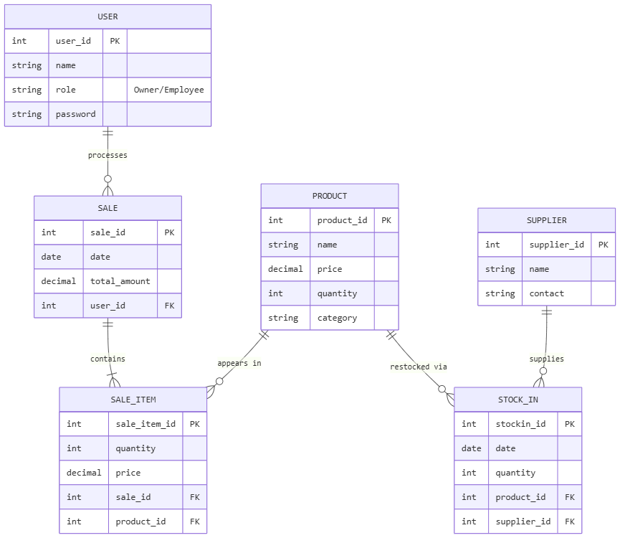

The diagram must depict the following entities: Supplier, Product, InventoryItem, StockMovement, Order, OrderItem, and PurchaseOrder. Relationships must show: Supplier to Product (1:M), Product to InventoryItem (1:M), InventoryItem to StockMovement (1:M), Order to OrderItem (1:M, composition), and Product to OrderItem (1:M).

4. Entity Descriptions
This section provides a comprehensive data dictionary for each entity in the ERD. Tables are grouped by their owning microservice to reflect the distributed data architecture.
Seven tables are documented across three microservice schemas: the Inventory Service owns Product, Category, InventoryItem, and StockMovement; the Procurement Service owns Supplier; and the Order Management Service owns SalesOrder and SalesOrderItem. For each table, every column is described with its exact field name, data type, length or precision, constraint rules, and a plain-language description of its purpose in the application.

INVENTORY SERVICE | PROCUREMENT SERVICE | ORDER MANAGEMENT
Product  Category  InventoryItem  StockMovement | Supplier | SalesOrder  SalesOrderItem

Inventory Service

Table: Product
The Product table is the master catalogue of every item tracked and sold through the Stock Flow system. It stores the commercial and physical attributes of each SKU. All inventory location records (InventoryItem) and sales line items (SalesOrderItem) reference this table. It is the central entity of the entire data model.

Product -- 13 columns
Field Name | Data Type | Length / Precision | Constraints | Description
product_id | SERIAL | -- | PK, NN, AI | System-generated auto-incrementing integer. Unique identifier for every product in the catalogue.
sku | VARCHAR | 50 chars | UK, NN | Stock Keeping Unit -- the human-readable product code printed on barcodes and used by staff for scanning operations at the POS and receiving dock.
name | VARCHAR | 150 chars | NN | Full display name of the product as shown on POS receipts, the manager dashboard, and forecasting reports.
category_id | INTEGER | -- | FK → Category, NN | Foreign key linking the product to its category. Used for grouping in analytics, filtering on the dashboard, and bulk procurement.
supplier_id | INTEGER | -- | FK → Supplier, NN | Foreign key identifying the primary supplier. Enables auto-generation of a Purchase Order directly from a low-stock alert without manual vendor lookup.
description | TEXT | Unlimited | -- | Detailed product description used in the admin catalogue panel and printed on formal supplier-facing documents.
unit_cost | DECIMAL | 10,2 | NN | Cost price per unit paid to the supplier (ZAR). Used to calculate gross margin on the Store Manager dashboard and in the Inventory Turnover Report.
unit_price | DECIMAL | 10,2 | NN | Retail selling price per unit (ZAR, VAT-inclusive). Displayed at the POS screen and printed on customer receipts.
reorder_point | INTEGER | -- | NN, DEF 0 | Minimum total stock-on-hand across all bins before the system triggers a low-stock alert and auto-generates a replenishment Purchase Order.
reorder_qty | INTEGER | -- | NN, DEF 0 | Suggested order quantity calculated from the Economic Order Quantity (EOQ) formula, pre-populated on auto-generated Purchase Orders.
is_active | BOOLEAN | -- | NN, DEF TRUE | Logical delete flag. Inactive products are hidden from the POS and forecasting but retained in SalesOrderItem for historical financial records.
created_at | TIMESTAMPTZ | -- | NN, DEF NOW() | UTC timestamp of record creation. Used in the immutable audit log required by NFR-SEC-01.
updated_at | TIMESTAMPTZ | -- | NN, DEF NOW() | UTC timestamp of the most recent update. Managed by a database trigger to ensure accuracy without application-layer intervention.

Table: Category
The Category table stores the product classification taxonomy used throughout the system for filtering, reporting, and bulk purchasing decisions. Categories appear as filter options on the manager dashboard, in the forecasting report, and in the admin product management panel. Each product belongs to exactly one category.

Category -- 5 columns
Field Name | Data Type | Length / Precision | Constraints | Description
category_id | SERIAL | -- | PK, NN, AI | System-generated unique identifier for the category.
name | VARCHAR | 100 chars | UK, NN | Display name of the category (e.g., Dry Goods, Beverages, Dairy, Frozen). Unique to prevent duplicate groupings.
description | TEXT | Unlimited | -- | Optional plain-language description of what product types belong in this category, used in admin documentation.
display_order | SMALLINT | -- | DEF 0 | Integer used to control the sequence in which categories appear in dropdown filters and navigation menus on the dashboard.
created_at | TIMESTAMPTZ | -- | NN, DEF NOW() | UTC timestamp of record creation for audit trail compliance.

Table: InventoryItem
The InventoryItem table represents the physical stock of a specific product held at a specific bin location within a warehouse. One product can exist in multiple bin locations across one or more warehouse sites. This separation of the conceptual Product entity from its location-specific physical record enables bin-level cycle counts, pick-path optimisation for warehouse staff, and per-location stock visibility on the manager dashboard.

InventoryItem -- 9 columns
Field Name | Data Type | Length / Precision | Constraints | Description
inventory_id | UUID | 36 chars | PK, NN | UUID primary key enabling distributed record creation across warehouse devices without requiring a central sequence counter.
product_id | INTEGER | -- | FK → Product, NN | Foreign key linking this stock record to its product master entry in the Product table.
warehouse_id | VARCHAR | 20 chars | NN | Identifier for the physical warehouse site (e.g., JHB-01, CPT-02). Used to scope inventory queries and pick-path routing.
bin_code | VARCHAR | 20 chars | NN | The specific shelf or bin identifier within the warehouse (e.g., C3-042). Displayed on the Warehouse Staff mobile dashboard to direct staff to the exact physical location.
qty_on_hand | INTEGER | -- | NN, DEF 0 | Physical count of units currently present at this bin location. Updated on every StockMovement event (sale, return, receipt, adjustment).
qty_reserved | INTEGER | -- | NN, DEF 0 | Units allocated to confirmed but not yet fulfilled customer orders. Deducted from qty_on_hand to calculate qty_available at the POS.
qty_available | INTEGER | -- | GENERATED (qty_on_hand − qty_reserved) | Computed available-to-sell quantity. Displayed at the POS to prevent overselling and displayed in low-stock alerts on the manager dashboard.
last_audited_at | TIMESTAMPTZ | -- | -- | Timestamp of the most recent completed cycle count at this bin. Used by the system to prioritise which bins are scheduled for the next audit.
last_received_at | TIMESTAMPTZ | -- | -- | Timestamp of the most recent goods receipt at this bin. Used in the receiving workflow history on the Warehouse Staff dashboard.

Table: StockMovement
The StockMovement table is an immutable, append-only event log that records every change to inventory quantity. Records are never updated or deleted -- each change to stock creates a new row. This design satisfies NFR-SEC-01 (immutable audit trail) and provides the chronological source data for the Analytics and Forecasting Service. The manager can reconstruct the exact stock level at any point in time by replaying this log.

StockMovement -- 8 columns
Field Name | Data Type | Length / Precision | Constraints | Description
movement_id | BIGSERIAL | -- | PK, NN, AI | Auto-incrementing 64-bit integer. Preserves strict global insertion order across all stock events for forensic timeline reconstruction.
inventory_id | UUID | -- | FK → InventoryItem, NN | Foreign key identifying the specific bin-level stock record that was affected by this movement.
event_type | VARCHAR | 30 chars | NN | Classification of the movement. Valid values: SALE (stock deducted by cashier), RETURN (stock added back after customer return), RECEIVE (stock added at goods receipt), AUDIT_ADJUSTMENT (manual correction after cycle count).
qty_change | INTEGER | -- | NN | Signed quantity delta. Negative for stock deductions (SALE). Positive for stock additions (RECEIVE, RETURN, AUDIT_ADJUSTMENT). The absolute sum of all qty_change values for an inventory_id reconstructs the current qty_on_hand.
reference_id | VARCHAR | 100 chars | -- | Optional reference to the originating transaction. Stores the SalesOrder UUID for SALE/RETURN events, or the PurchaseOrder ID for RECEIVE events, enabling drill-through navigation from the audit log.
user_id | VARCHAR | 100 chars | NN | Authenticated user identifier of the person who triggered the movement. Used to attribute discrepancies during stock investigation.
notes | TEXT | Unlimited | -- | Free-text field for recording additional context, such as the specific damage description during an AUDIT_ADJUSTMENT or the supervisor who authorised a manual correction.
occurred_at | TIMESTAMPTZ | -- | NN, DEF NOW() | UTC timestamp with time zone of the event. The primary ordering key for audit log queries and sales trend time-series analysis.

5. Relationship Justification
This section provides the rationale for each relationship cardinality defined in the Entity Relationship Diagram, demonstrating traceability from the data model to the business processes and system requirements.
Supplier to Product (One-to-Many)
One supplier provides many products. In this system model, each product Stock Keeping Unit is sourced from a single primary supplier. This design choice simplifies the auto-generation of Purchase Orders by creating a direct, unambiguous link between a low-stock alert and the vendor to whom the order must be transmitted. This supports the automated Replenishment business process and the auto-generated Purchase Order functional requirement (FR-PRO-01).
Product to InventoryItem (One-to-Many)
A single product can have physical stock distributed across multiple warehouse locations and bin codes. This relationship is fundamental to the Inventory Audit and Online Order Fulfillment processes, which require the system to direct staff to the exact physical location of the stock. Without this separation between the product master and location-specific inventory records, the system could not support the bin-level tracking required for efficient pick paths and cycle counts.
Order to OrderItem (One-to-Many, Composition)
An Order is composed of one or more line items. This is a composition relationship: an OrderItem record cannot exist independently of its parent Order. If an Order is cancelled, all associated OrderItems are logically removed. This structure maintains transactional integrity and directly supports the Sales Transaction and Process Returns business processes, where the system must retrieve the complete details of a past transaction, including the specific items purchased and their prices at the time of sale.
Product to OrderItem (One-to-Many)
One product appears as a line item on many different orders over time. The OrderItem table stores a point-in-time snapshot of the Stock Keeping Unit and unit price, creating an immutable financial record. This design is essential because product prices may be updated in the Product table, but historical orders must always reflect the price at which they were transacted. This is critical for accurate financial reporting, customer receipt reprinting during returns, and audit compliance.
InventoryItem to StockMovement (One-to-Many)
A single inventory location record accumulates many movement events over its lifetime. The StockMovement table functions as an append-only event store, capturing every stock deduction, addition, and adjustment as an immutable log entry. This relationship satisfies the accountability and auditability requirement of NFR-SEC-01, enabling the manager to trace any discrepancy to a specific user, timestamp, and event type.

6. Technology Choice
This section presents the justification for selecting PostgreSQL as the primary relational database management system for the system. The justification is structured around the system's functional and non-functional requirements, and includes an evaluation of rejected alternatives.

Selected Technology: PostgreSQL (Managed Cloud Instance)
PostgreSQL is selected as the relational database management system for all microservices. The following criteria support this decision.
ACID Compliance and Transactional Integrity
PostgreSQL provides full Atomicity, Consistency, Isolation, and Durability compliance. Its Multi-Version Concurrency Control mechanism and support for serializable transaction isolation levels are essential for preventing lost updates in high-concurrency inventory operations. This ensures that when two concurrent sales transactions attempt to purchase the final unit of a product, only one will succeed, and the stock count will be accurately decremented to zero, not to a negative value. This capability directly satisfies the data integrity requirement of NFR-REL-02, which specifies a Recovery Point Objective of near-zero for transactional data.
Support for the Database per Service Pattern
The microservices architecture requires each service to own its private data store, as specified in NFR-MAINT-01. PostgreSQL's native schema support allows for logical data isolation within a single managed cloud instance, such as Amazon Relational Database Service. This approach simplifies operational management for the Small and Medium Enterprise context, keeping the forty-eight hour deployment roadmap achievable by reducing infrastructure complexity without sacrificing the data sovereignty principle central to the Database per Service pattern.
Native JSON and Semi-Structured Data Support
PostgreSQL supports the JSONB data type, which allows efficient storage and indexing of semi-structured data. This is critical for the Integration Service, which uses the Adapter Pattern to communicate with external vendor Application Programming Interfaces such as Square Point-of-Sale and UPS tracking. External systems may return payloads with unpredictable or versioned schemas. The system stores raw Application Programming Interface responses in JSONB columns for full auditability, while core transactional data remains in strictly typed relational columns. This approach satisfies the traceability requirement of NFR-SEC-01 without compromising the relational integrity of operational data.
Analytical Query Performance
PostgreSQL provides advanced indexing capabilities, including GiST and GIN indexes, which accelerate full-text search on product catalogs. This is necessary to meet the performance target specified in NFR-PERF-01, which requires search results to return within five hundred milliseconds. Furthermore, PostgreSQL's mature query planner and native support for Window Functions enable the complex time-series calculations required by the Analytics and Forecasting Service, such as moving averages and exponential smoothing, without necessitating a separate analytical database.
Open Source Licensing and Cost-Effectiveness
PostgreSQL is released under an open-source license with no per-core or per-processor licensing fees. This is a critical factor for Small and Medium Enterprises, for whom enterprise database licensing models represent a prohibitive barrier to technology adoption. The availability of fully managed, pay-as-you-go cloud database instances further aligns with the Small and Medium Enterprise need for predictable and scalable operational expenditure, directly addressing the problem statement's identification of cost as a key limitation of existing solutions.

Rejected Alternatives
Oracle Database
Oracle Database was rejected primarily due to its complex and expensive licensing model. The per-core licensing costs and mandatory support fees are incompatible with the budgetary constraints of the Small and Medium Enterprise market segment. Additionally, the administrative complexity of Oracle databases requires specialized skills, increasing operational overhead and creating a dependency that contradicts the project objective of an accessible, maintainable solution.
MySQL
MySQL, while a capable open-source relational database management system, was rejected on technical grounds. Its handling of high-concurrency transactional isolation has historically been less robust than PostgreSQL's Multi-Version Concurrency Control implementation, introducing a marginally higher risk of data integrity issues under peak load conditions. Furthermore, MySQL offers a more limited analytical function set, particularly regarding Window Functions and Common Table Expressions, which are extensively used by the Analytics and Forecasting Service. Selecting MySQL would have required the introduction of an additional analytical data store, adding architectural complexity that contradicts the modularity and simplicity objectives of the design.

